Project Interim Report
on
File Compression Simulator
(Using Core Java & OOP Concepts)
RU-100-01-00012
Object oriented Programming with Java


RUNGTA INTERNATIONAL SKILLS UNIVERSITY
SESSION: 2025-26

Subject teacher name Submitted By :-
(Shivansh Mehta) Student name:- Anirudh kumar..
ERP ID :- RU-25-10197

Submitted To :

RUNGTA INTERNATIONAL SKILLS
UNIVERSITY (BHILAI) ,CG
SCHOOL OF COMPUTER SCIENCE ENGINEERING

INDEX
S.NO | TITLE | PAGE NUMBER
1) | Abstract | 1
2) | Introduction | 1-2
3) | Objectives | 2-3
4) | Scope | 3-4
5) | System Requirements | 4-5
6) | Methodology | 5-6
7) | FlowChart | 6-7
8) | Class Diagram | 7-8

INDEX
S.NO | TITLE | PAGE NUMBER | REMARKS
9) | Conclusion | 8-9
10) | References | 9-10

Abstract
The Customer Feedback Analysis System is a software application designed to collect, store, and analyze customer feedback. In today’s competitive environment, customer satisfaction plays a crucial role in the success of any business, making it important to understand and evaluate customer opinions.
The main objective of this system is to manage customer reviews, ratings, and suggestions in a structured manner. The system processes the feedback and converts it into meaningful information, such as identifying positive, negative, and neutral responses. This helps organizations understand customer expectations and identify common issues.
The system also generates reports and graphical representations, making it easier for management to make informed decisions. By using this system, companies can improve their products and services and enhance overall customer satisfaction.
Thus, the Customer Feedback Analysis System serves as an effective tool for business growth and better customer relationship management.

Introduction.
The Customer Feedback Analysis System is a software application used to collect and analyze customer feedback such as reviews and ratings. It helps in identifying customer opinions and improving products and services.
The system also generates reports, making decision-making easier and enhancing customer satisfaction.

Objectives
- To collect customer feedback efficiently
- To analyze feedback (positive, negative, neutral)
- To understand customer satisfaction levels
- To identify common problems and trends
- To improve products and services
- To generate reports for better decision-making

Scope
The Customer Feedback Analysis System can be used in various organizations to collect and analyze customer feedback efficiently. It helps businesses understand customer needs, identify problems, and improve their products and services.
The system can be applied in areas like e-commerce, retail, and service industries. It also supports future enhancements such as advanced analytics and real-time feedback processing.

System Requirements
1. Hardware Requirements
- Computer/Laptop
- Minimum 4 GB RAM
- Processor: Intel i3 or above
- Hard Disk: At least 500 GB

2. Software Requirements
- Operating System: Windows / Linux
- Programming Language: Java / Python / PHP
- Database: MySQL / Oracle
- Web Browser: Chrome / Edge
- IDE: VS Code / Eclipse / NetBeans

3. Other Requirements
- Internet connection (optional for web-based system)
- Basic knowledge of computer operation

Methodology
The development of the Customer Feedback Analysis System follows a structured approach:
- Data Collection
Customer feedback is collected through forms, reviews, or ratings.
- Data Storage
The collected data is stored in a database for further processing.
- Data Processing
The system processes the feedback to organize and clean the data.
- Analysis
The feedback is analyzed to identify positive, negative, and neutral responses.
- Report Generation
The system generates reports and charts for easy understanding.
- Result Interpretation
The analyzed data is used to help management make better decisions and improve service.

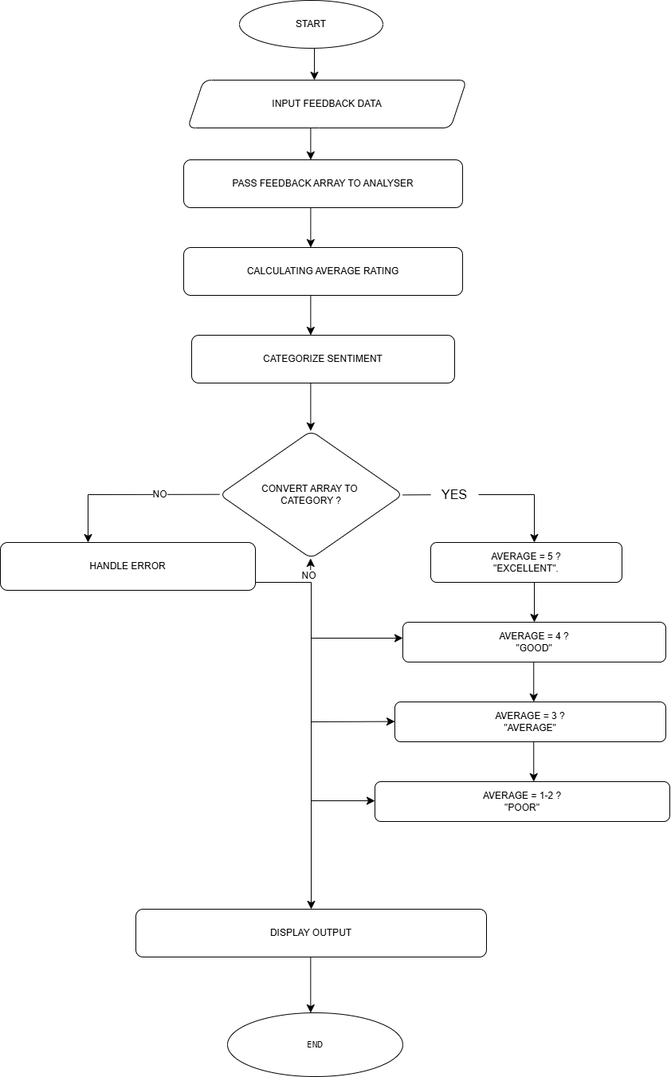
Class Diagram
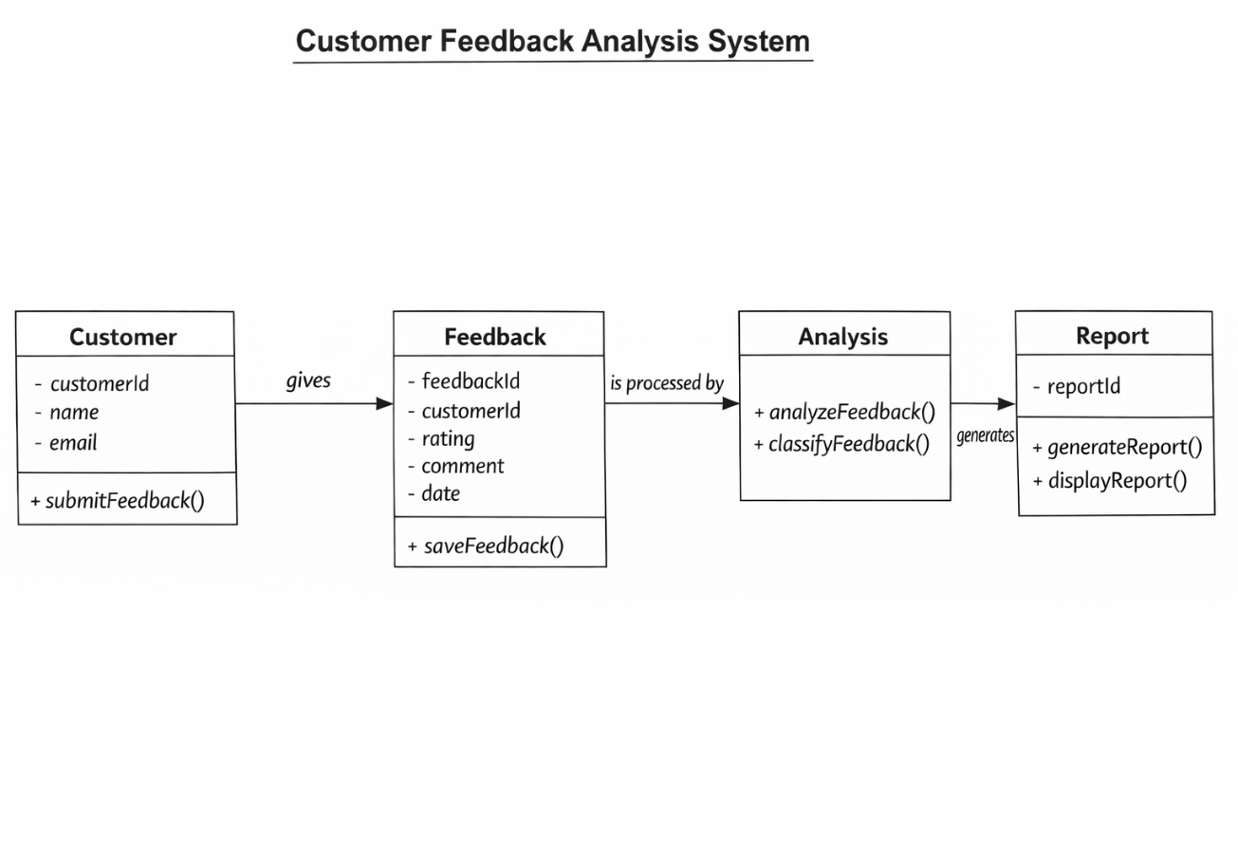

Conclusion
The Customer Feedback Analysis System is an effective tool for collecting and analyzing customer feedback in a structured way. It helps organizations understand customer opinions, identify common issues, and improve their products and services. By generating reports and insights, the system supports better decision-making and enhances customer satisfaction. Overall, this system plays an important role in improving business performance and building strong customer relationships.

Reference:
Work:-
. Collects customer feedback through forms or surveys
. Stores feedback data in a database
. Analyzes feedback (ratings, reviews, comments)
. Performs sentiment analysis (positive / negative / neutral)
. Identifies customer satisfaction level
. Generates reports and graphs for decision-making
. Helps improve products and services based on feedback
. Provides admin dashboard to monitor responses
Website:-
. GeeksforGeeks – https://www.geeksforgeeks.org
. Google Scholar – https://scholar.google.com

Code:
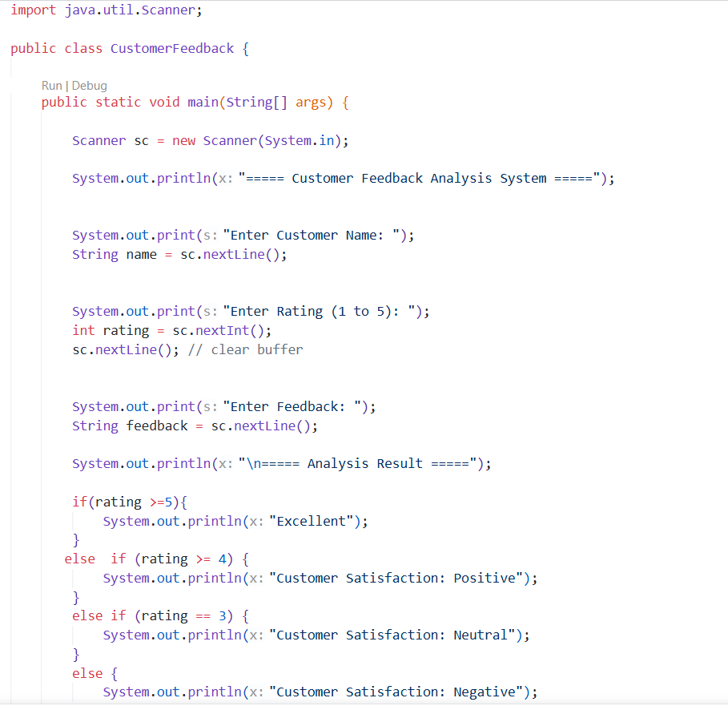
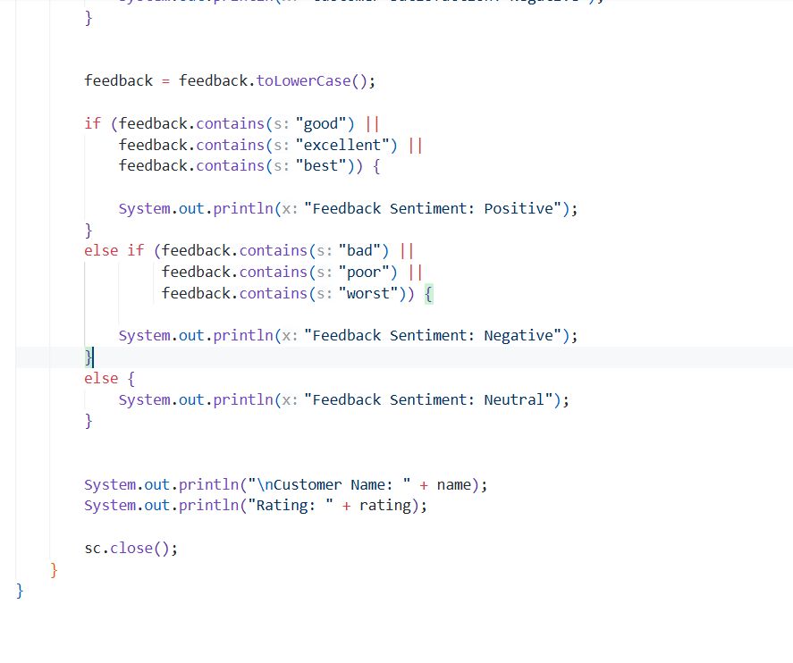
Output:
